**Lab16 – Understanding Zone-Redundant Storage (ZRS) - Azure**

**Zone Redundant Storage (ZRS)**

Zone-redundant storage (ZRS) replicates your data synchronously across three storage clusters in a single region. Each storage cluster is physically separated from the others and is located in its own availability zone (AZ). Each availability zone—and the ZRS cluster within it—is autonomous and includes separate utilities and networking features.

When you store your data in a storage account using ZRS replication, you can continue to access and manage your data if an availability zone becomes unavailable. ZRS provides excellent performance and low latency. ZRS offers the same [scalability targets](https://docs.microsoft.com/en-us/azure/storage/common/storage-scalability-targets) as [locally redundant storage (LRS)](https://docs.microsoft.com/en-us/azure/storage/common/storage-redundancy-lrs).

Consider ZRS for scenarios that require consistency, durability, and high availability. Even if an outage or natural disaster renders an availability zone unavailable, ZRS offers durability for storage objects of at least 99.9999999999% (12 9's) over a given year.

For more information about availability zones, see [Availability Zones overview](https://docs.microsoft.com/azure/availability-zones/az-overview).

**Support coverage and regional availability**

ZRS currently supports standard general-purpose v2 account types. For more information about storage account types, see [Azure storage account overview](https://docs.microsoft.com/en-us/azure/storage/common/storage-account-overview).

ZRS is available for block blobs, non-disk page blobs, files, tables, and queues.

ZRS is generally available in the following regions:

* US East
* US East 2
* US West 2
* US Central
* North Europe
* West Europe
* France Central
* Southeast Asia

**Topology**

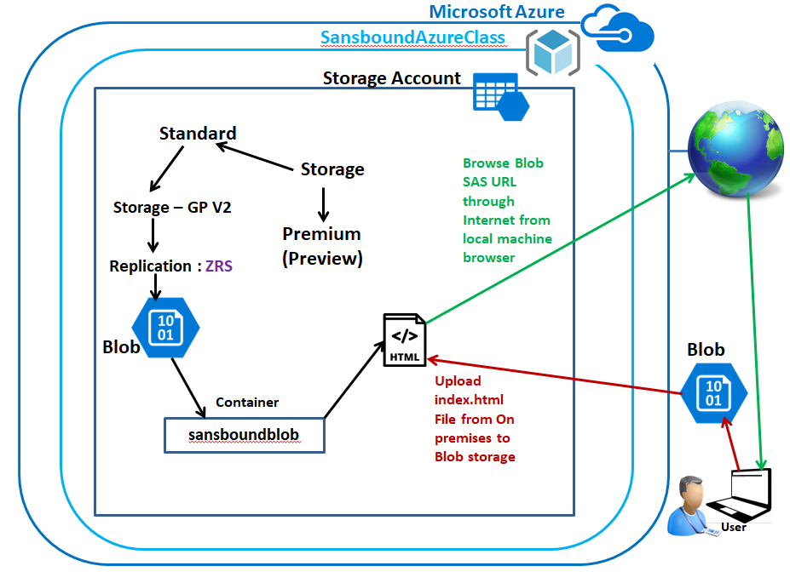

**Back-End Topology (ZRS):**

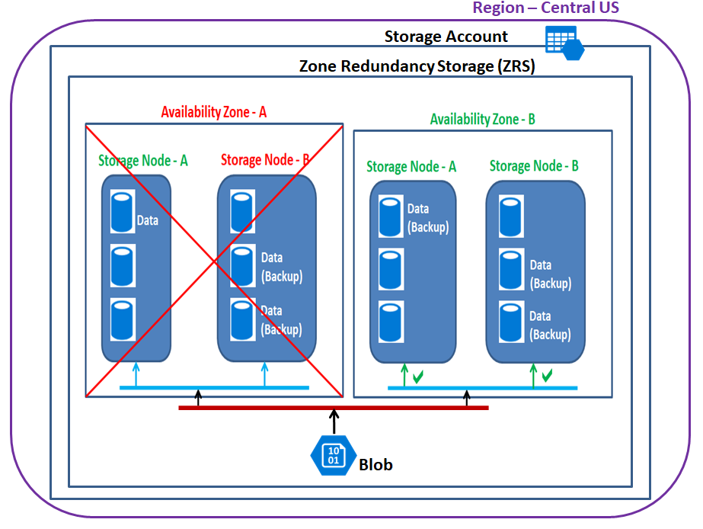

In Azure portal, click “Resource groups”.

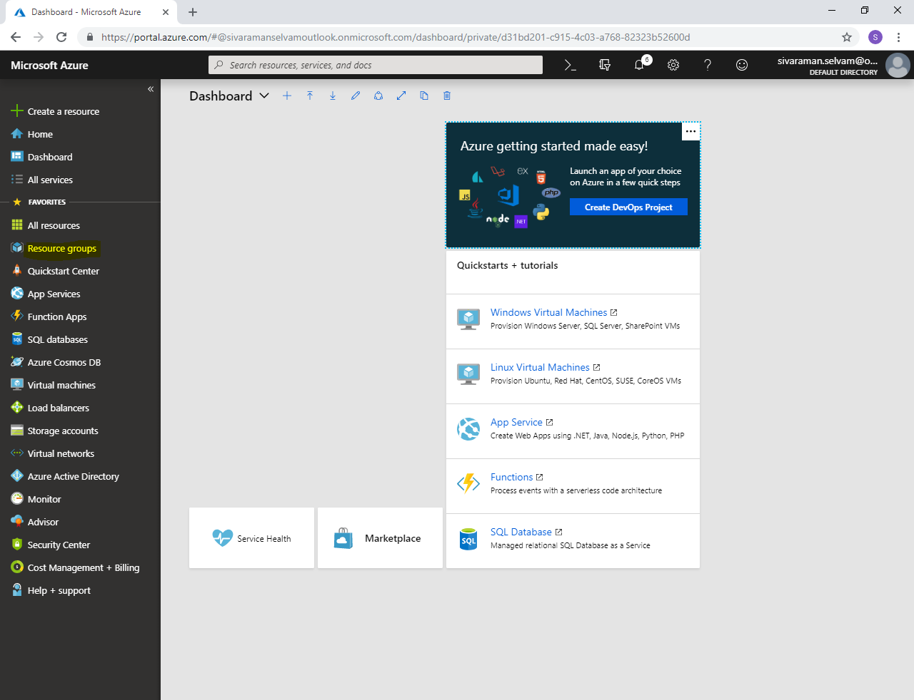

In **“Resource groups”** click **“Add”**.

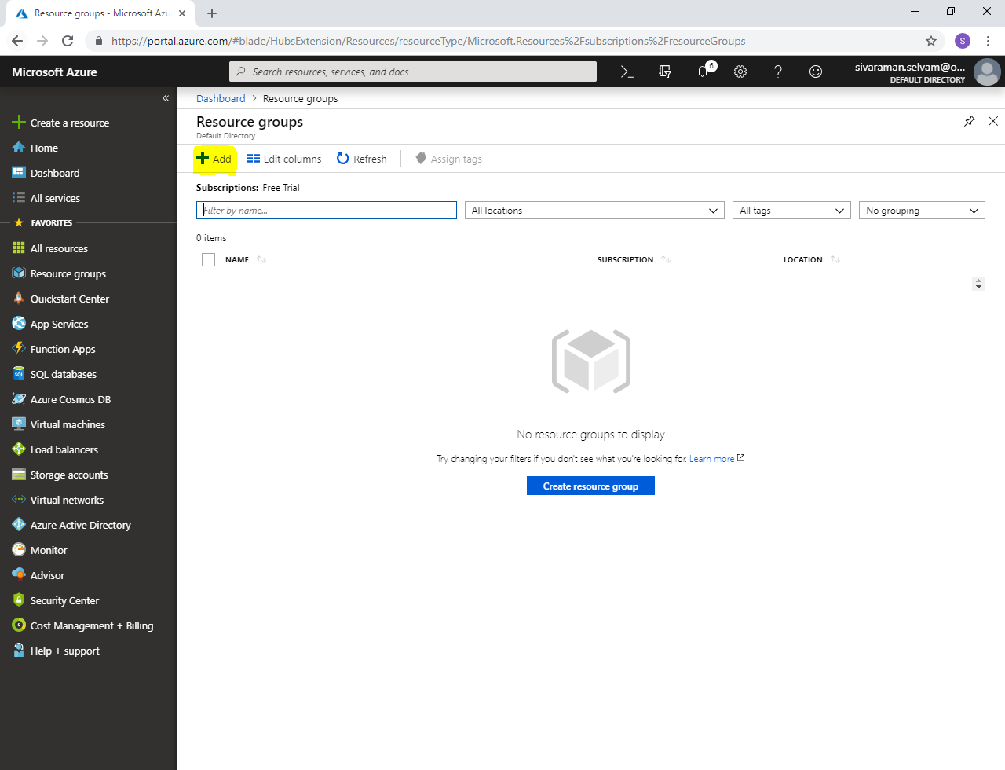

In **“Resource group name”**,

Type **“Resource group name”** as **“SansboundAzureClass”**.

Select **“Subscription”** as **“Free Trial”**.

Select **“Resource group location”** as **“Central US”.**

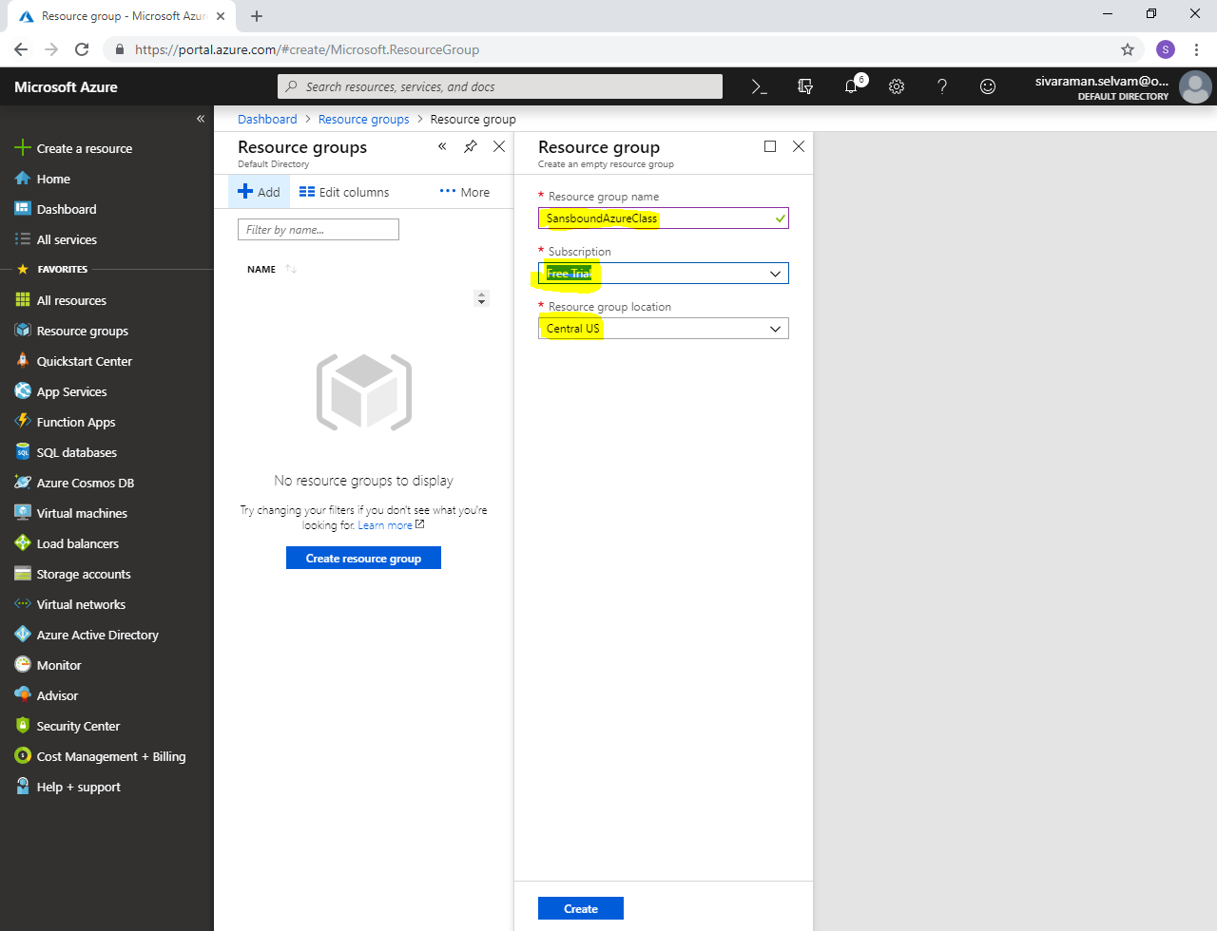

Click **“Create”**.

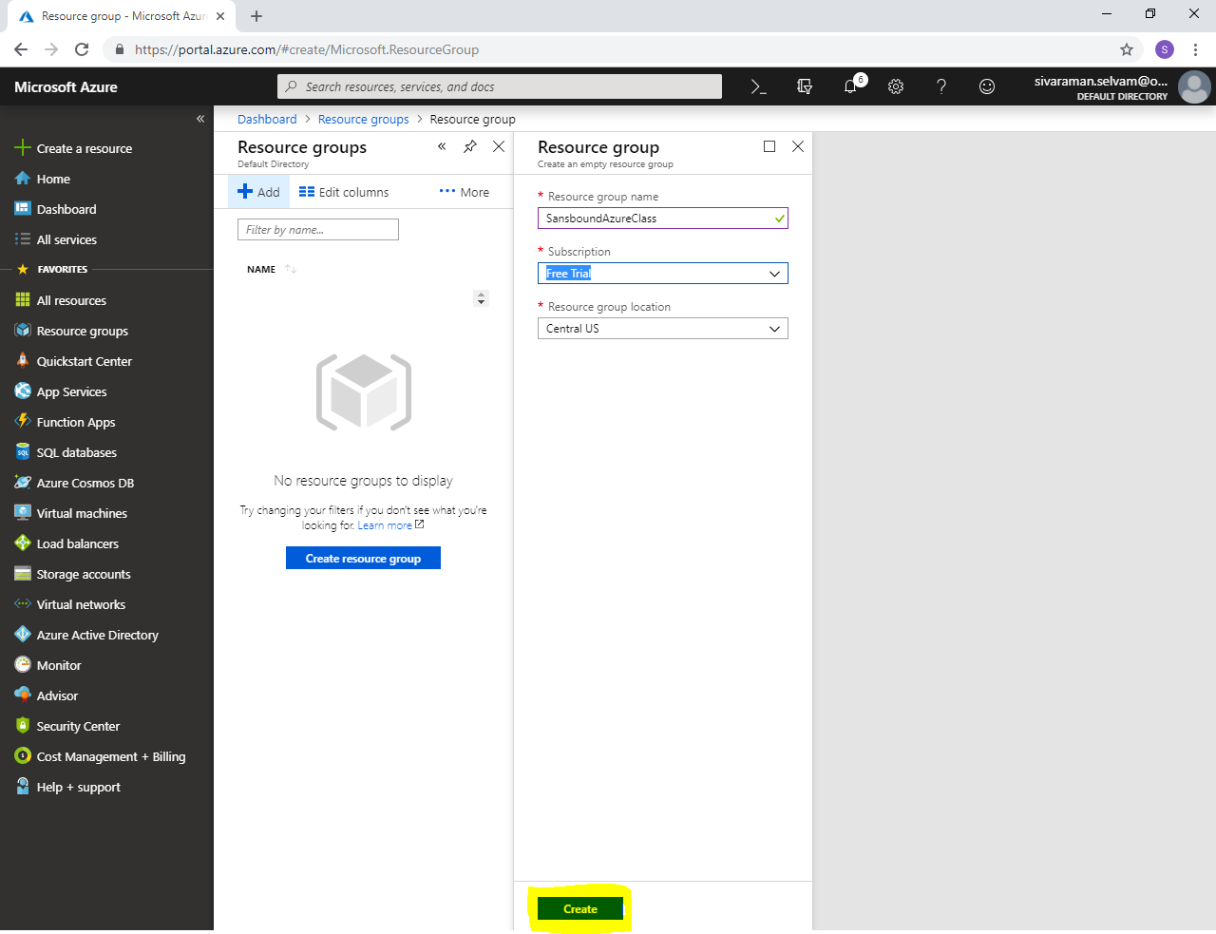

In Azure portal, click **“Storage accounts”**.

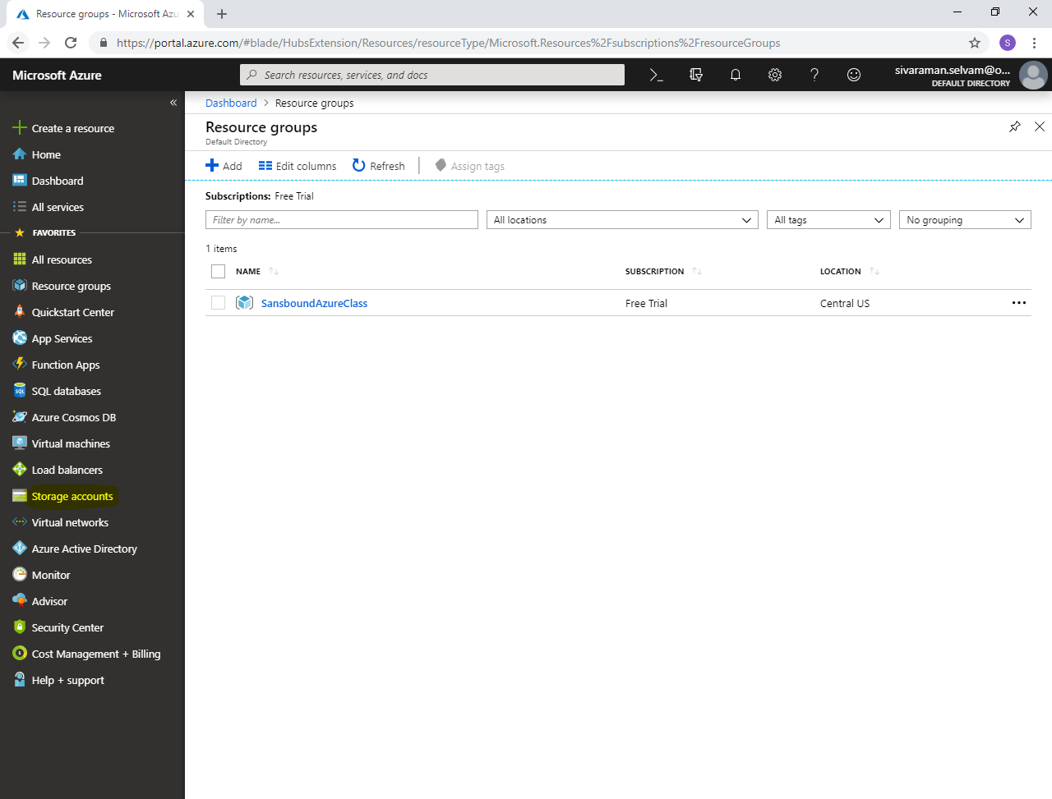

Click **“Add”**.

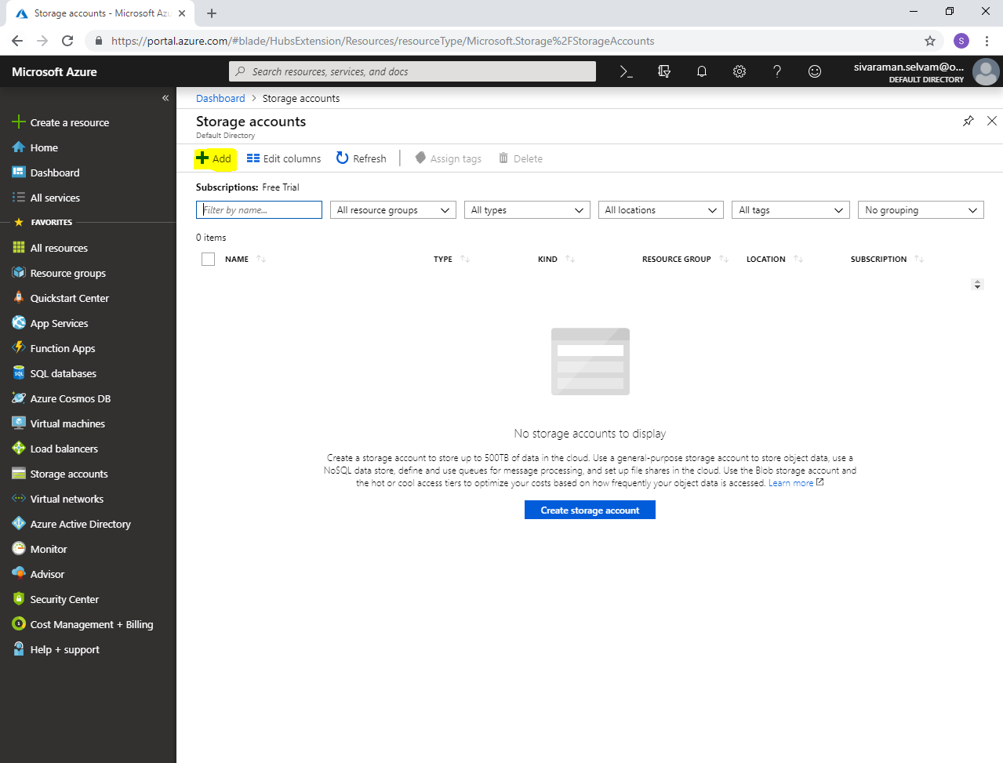

While create storage account,

Select **“Subscription”** as **“Free Trial”**.

Select “Resource group” as **“SansboundAzureClass”**.

Type **“Storage account name”** as **“sansboundblob”**.

Select **“Location”** as **“Central US”**.

Select **“Performance”** as **“Standard”**.

Select **“Account kind”** as **“Storage V2”**.

Select **“Replication”** as **“Zone Redundant storage”**.

Select **“Access tier”** as **“Hot”**.

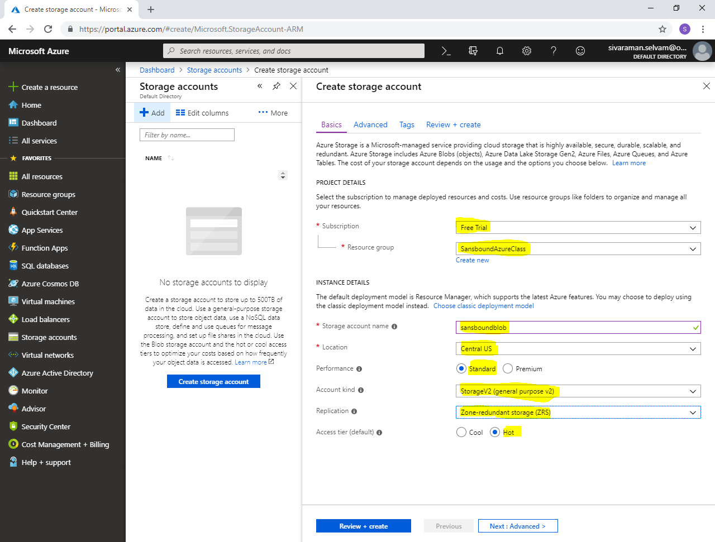

Click **“Next : Advanced >”**.

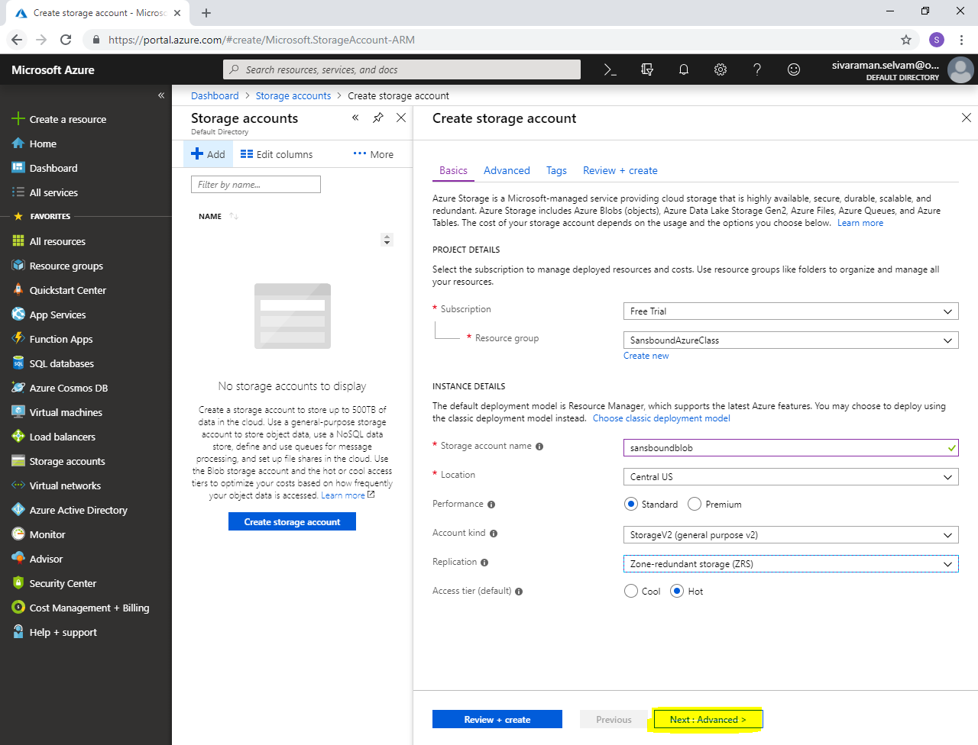

Click **“Next : Tags >”**.

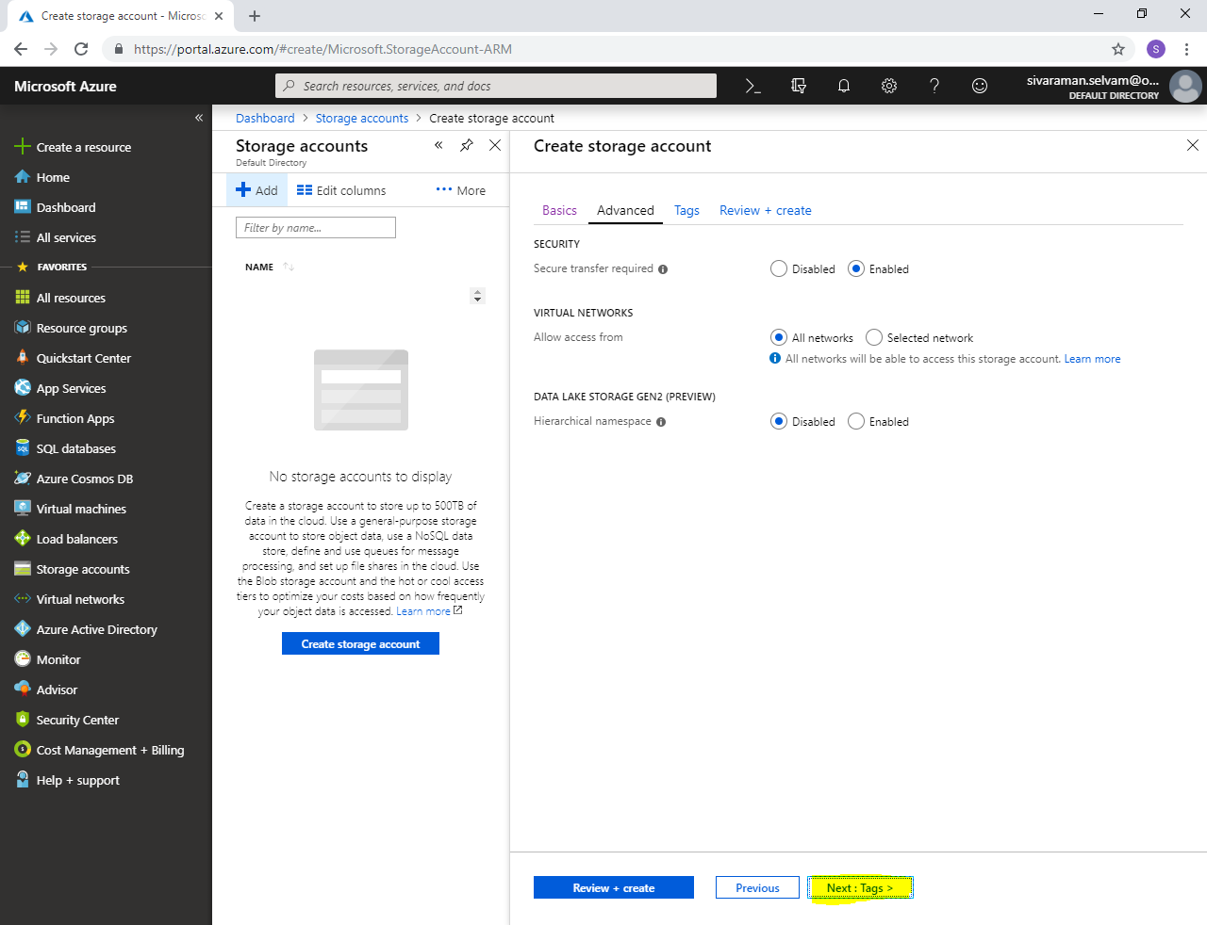

In **“Tags”**,

Type **“KEY”** as **“Name”** and **“VALUE”** as **“Sansbound-Blob”**.

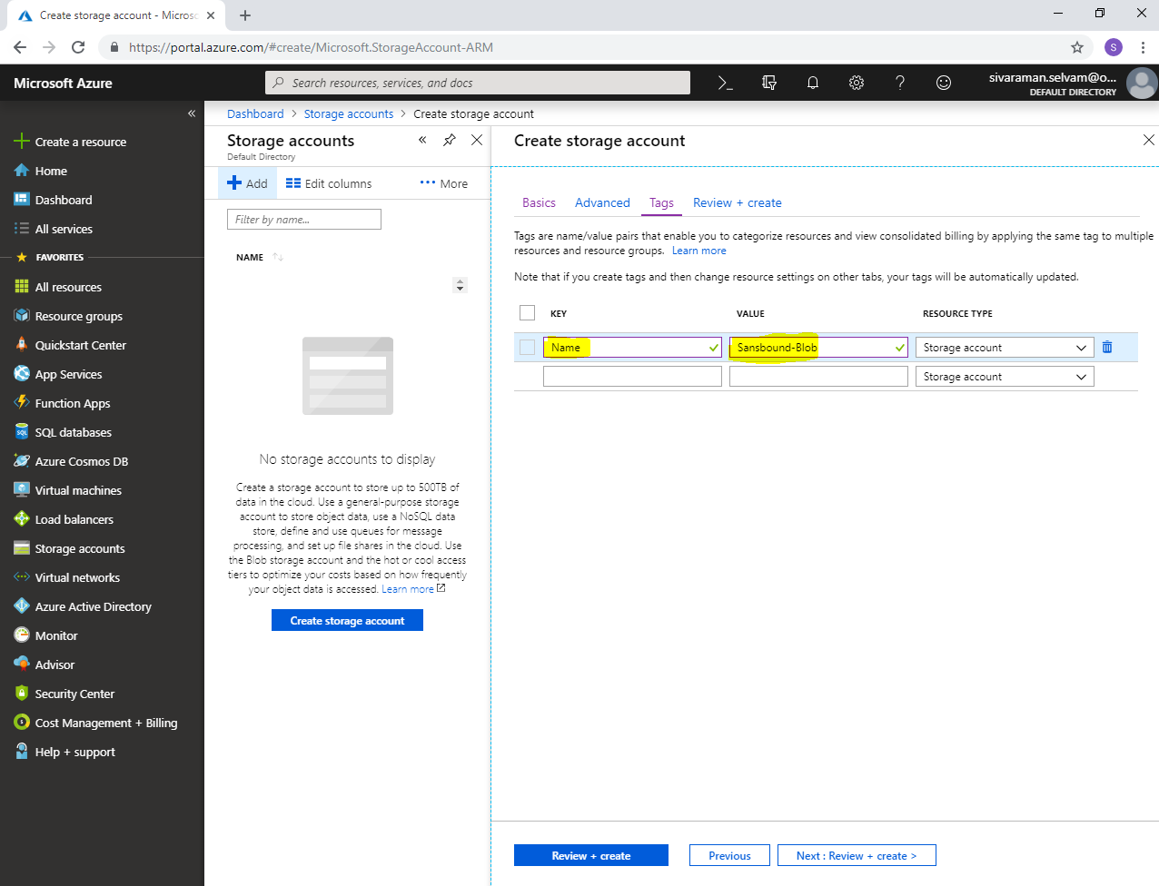

Click **“Next : Review + create”**.

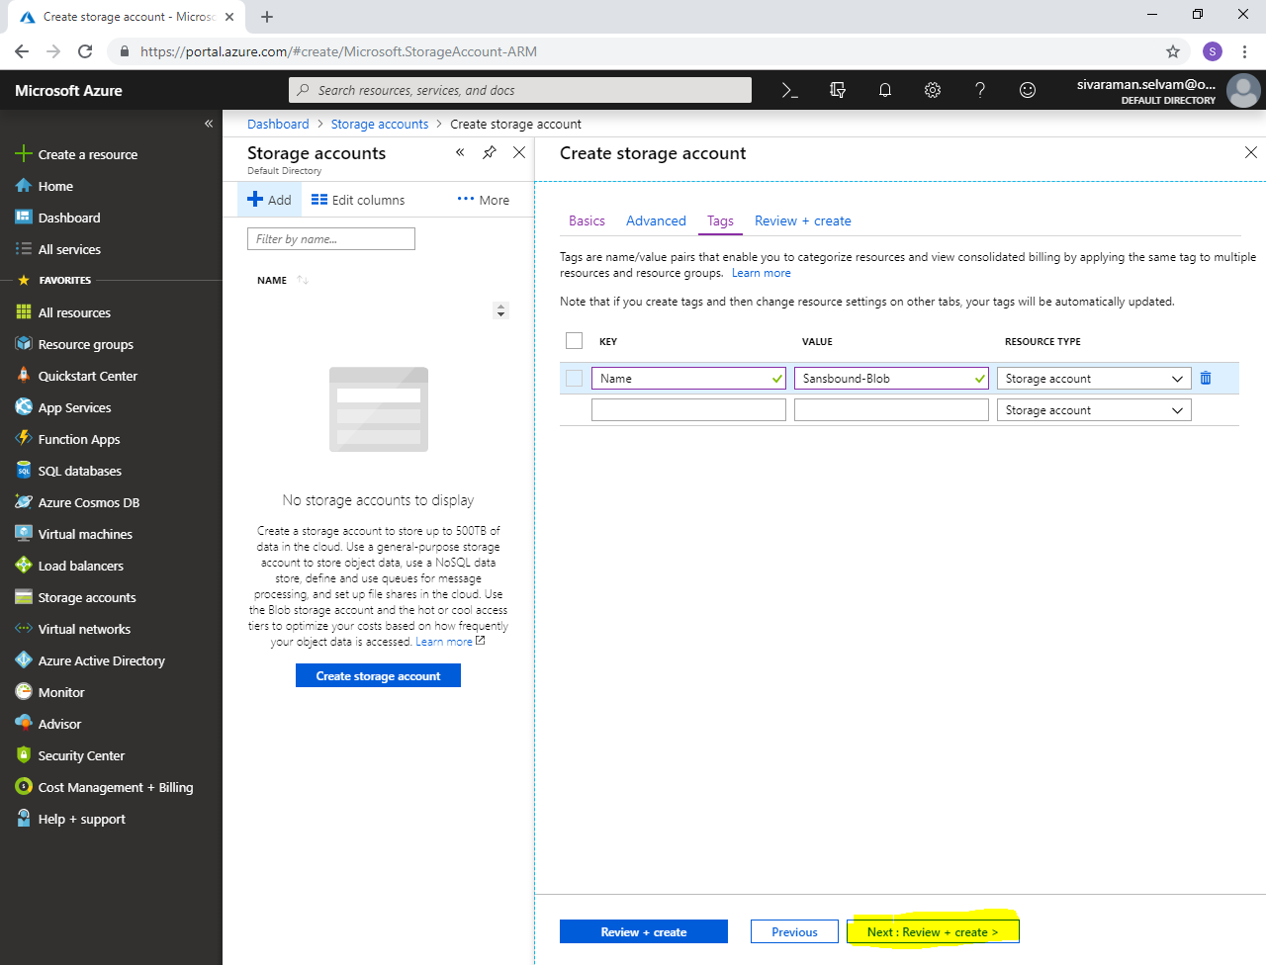

Click **“Create”**.

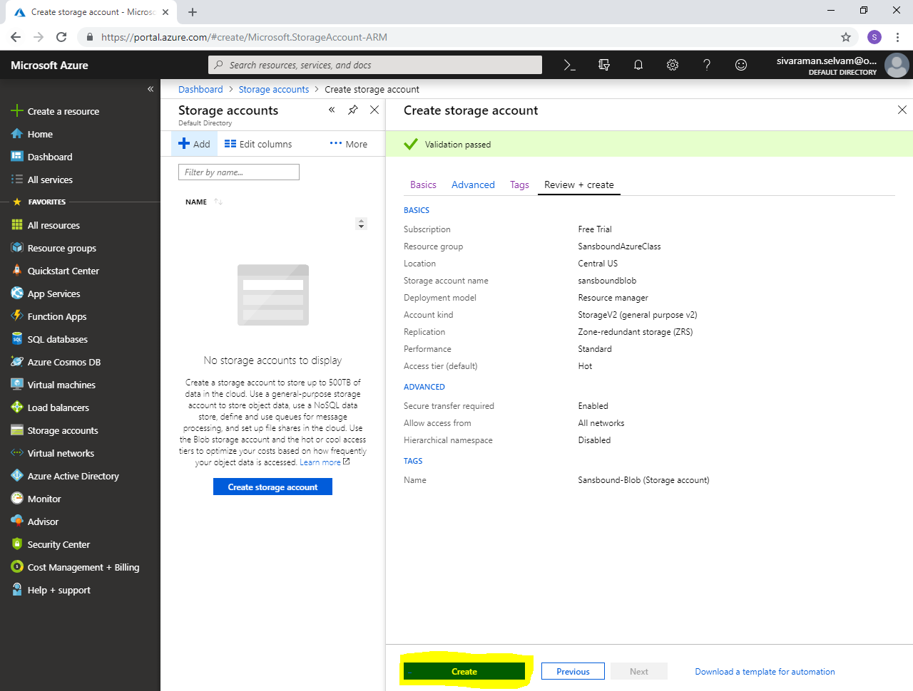

Click **“Go to resource”**.

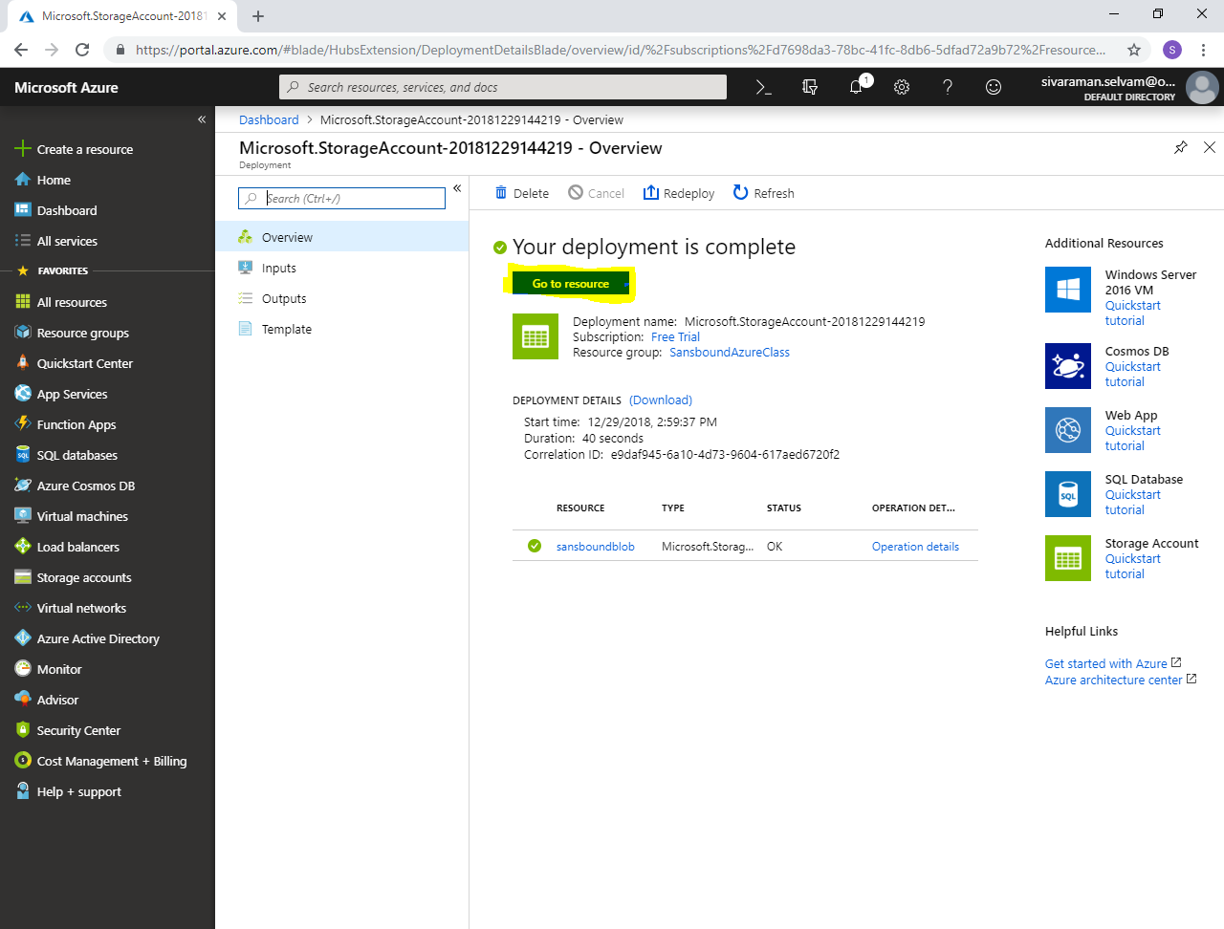

In “sansboundblob” storage account, click blobs.

Then create container and upload the files into the container.

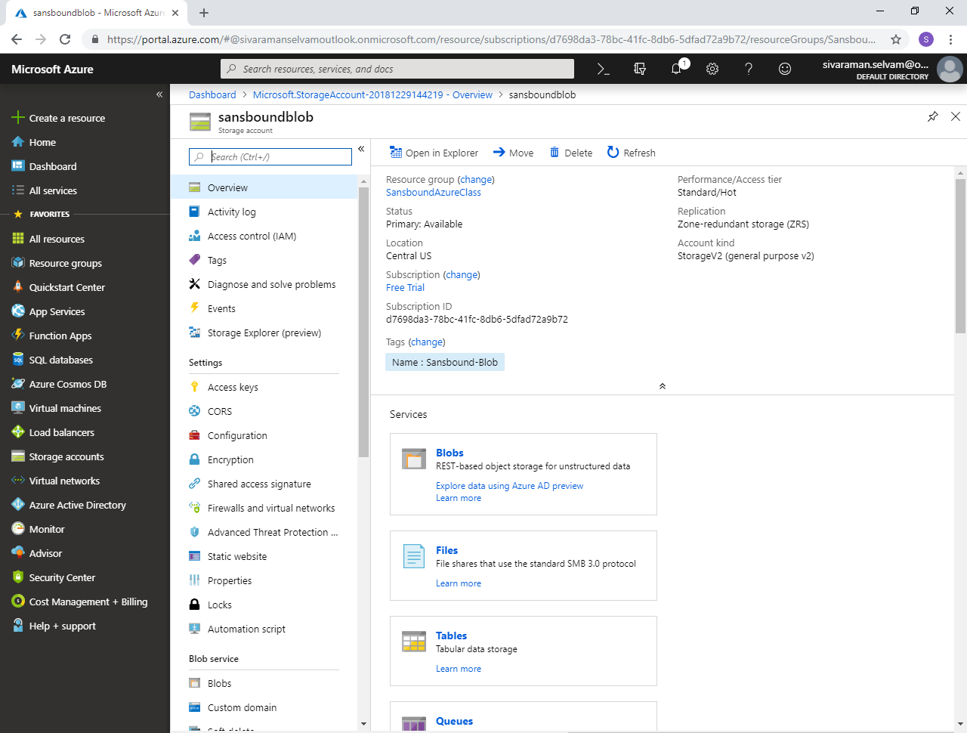

Note : Whatever the data you have stored in that container it will kept three copies in each Availability zone. If the Availability Zone – A fails, then you can able to access data from Availability Zone – B. That’s the reason we have preferred Zone-based Redundant Storage.